BUS IN 8051

* **Definition:**

Bunch of wires/data is called bus.

* **Type Of Buses:**

1. Data Bus
2. Address Bus
3. Control Bus

* 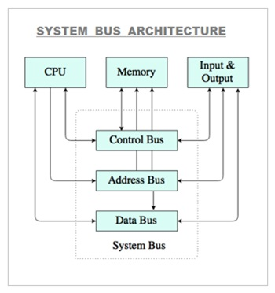**Architecture Of Buses:**
* **Data Bus:**

A data bus can operate as a parallel or serial bus depending on how the data is carried.

A parallel bus is used in more complex connection that must carry more than one bit at a time.

* **Address Bus:**

An element in a computer CPU that transmit the location of stored information.

The dada bus allows the CPU to send the address to ram & the data bus allows.

* **Control Bus:**

Control bus is computer bus that is used by the CPU to communicate with device that one contained with the computer.